**Class assignmet.**

Q1.A teacher wants to set up random pairs out of pupils to participate in a task, where Group A pupils are advanced and Group B pupils need assistance. Design the solution that will do that**.** Display the random pairs.

[6 marks]

|  |  |  |  |  |
| --- | --- | --- | --- | --- |
| Group A | Bob | John | Nora |  |
| Group B | Cecil | Rezaq | Ralph | Troy |

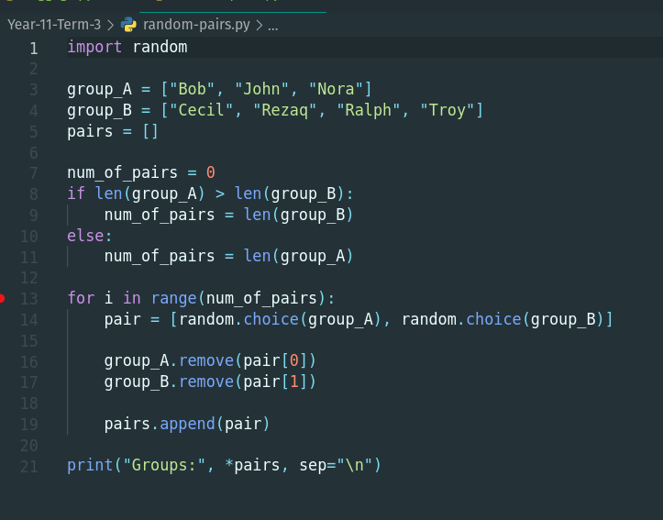

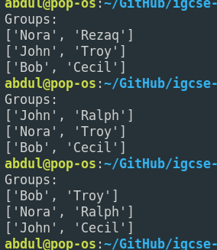

Question 2.

A programmer is coding a menu interface which displays 3 options to the user. The use then presses 1 for the first option, 2 for the second option, 3 for the third option, each of these calls a procedure such as option1(), option2(), option(3). Code a solution that will validate user input to be only 1, 2 or 3 and then call the corresponding procedure.

|  |
| --- |
|  |

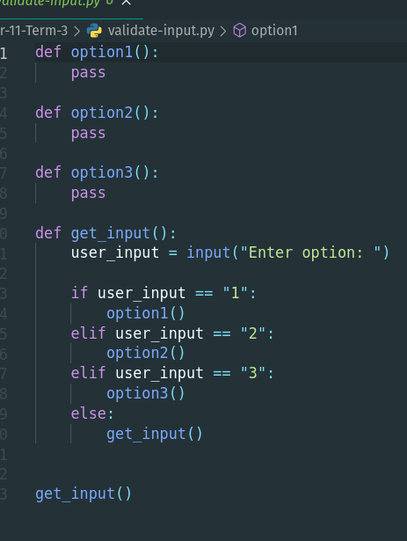

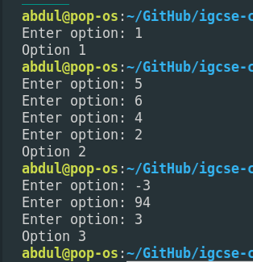

You are writing a program for an airline that calculates the price for oversized baggage (if any) that air travellers have to pay. The rules are given as follows:

Any baggage that is under 10 kg and is no larger than 40 by 30 cm, ignoring depth, can go free of charge.

Any baggage that doesn’t satisfy the first criteria, up to 20 kg and 60 by 40 cm, costs £50.

Any baggage that doesn’t satisfy the first and second criteria, is charged £10 per kg.

Baggage over 100 kg and 150 by 150 cm is not allowed at all and should be sent separately by freight. In this case, the cost variable gets assigned an rogue value of -99.

[10 marks]

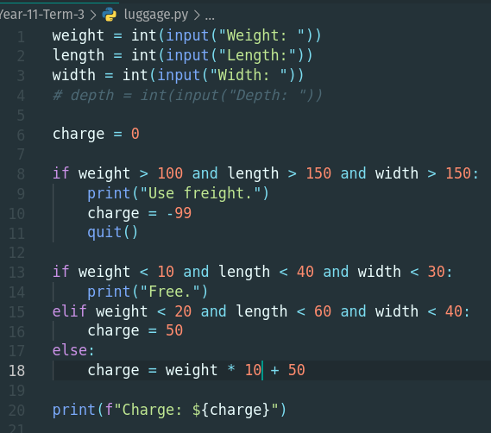

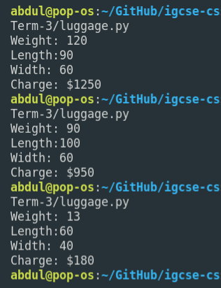

Question 3. Complete the table using the program to calculate the values. [6 marks]

|  |  |  |  |  |
| --- | --- | --- | --- | --- |
|  | **Cost (£)** | **Weight (kg)** | **Length (cm)** | **Width (cm)** |
| 1 | 1250 | 120 | 90 | 60 |
| 2 | 950 | 90 | 100 | 60 |
| 3 | 180 | 13 | 60 | 40 |
| 4 | 270 | 22 | 60 | 40 |
| 5 | 0 | 9 | 30 | 20 |
| 6 | 550 | 50 | 150 | 100 |

Question 4.

You are given the following code:

1. order:=""
2. price:=0
3. SM_COFFEE:=1
4. MD_COFFEE:=1.25
5. LG_COFFEE:=1.4
6. MUFFIN:=2
7. ONE_L_WATER:=1.1
8. ONE_HALF_L_WATER:=1.3
9. SURCHARGE=1.1
10. OUTPUT “Press 1 to buy coffee, 2 for no coffee"
11. INPUT choice //no validation
12. IF choice=1 THEN
13. OUTPUT “Press 1 for small, 2 for medium, 3 for large" //cof. size
14. INPUT choice //no validation
15. //quantity
16. OUTPUT “How many coffees of this type?"
17. INPUT quantity //no validation
18. IF choice=1 THEN
    1. order:=order+" small coffee"
    2. price=price+SM_COFFEE*quantity
19. ELSE IF choice=2 THEN
    1. order:=order+" medium coffee"
    2. price=price+MD_COFFEE*quantity
20. ELSE IF choice=3 THEN
    1. order:=order+" large coffee"
    2. price=price+LG_COFFEE*quantity
21. END IF
22. //milk
23. OUTPUT “Press 1 for black coffee, 2 for white"
24. INPUT choice //no validation
25. IF choice=1 THEN
    1. order:=order+" black"
26. ELSE IF choice=2 THEN
    1. order:=order+" white"
27. //sugar
28. OUTPUT “Press 1 for no sugar, 2 for sugar"
29. INPUT choice //no validation
30. IF choice=1 THEN
    1. order:=order+" no sugar"
31. ELSE IF choice=2 THEN
    1. order:=order+" with sugar"
32. END IF
33. Identify a line which shows use of a variable. (1)

Line 1.

1. State the data type of “LG_COFFEE” in line 5. State the reason for choosing this data type. (2)

Floating point as the value has a decimal place. Also allows for calculations to be done, for example the price of the order.

1. Identify a line which shows use of a built-in function. (1)

Line 28. OUTPUT.

1. Identify a line (s) which shows selection (1)

Line 25.

1. Explain how would you change the program if the customer wants to buy more than one products. ( 2)

Implement a indefinite loop asking for one product at a time, storing it in a list.

1. What values will the customer enter for white medium coffee with sugar (1)

2, 2, 2.